assessment 2: Team project

COSC2196 – Introduction to Information Technology A2

Contents

Team25 - Profile 3

Team Name 3

Team25 Members 3

Niki Arrogante 3

Tamara Brice 5

Debborah Bryce 7

Samuel Claydon 9

Caden Maxwell 11

Jake Waterson 13

Comparing Test Results 15

Comparing Ideal Jobs 15

Tools 16

Microsoft Teams 17

GitHub 19

Trello 21

Industry Data – Research by Debborah Bryce 23

Ideal Job Titles and their Demand Rankings 23

Skillsets – IT-Specific Rankings 24

Software Development (Caden & Niki) 24

Computer Repair / Hardware Technician (Sam) 24

Developmental operations, Infrastructure Automation Consultant (Mara) 24

Data Analyst/Scientist (Debborah) 24

Software Engineer (Jake) 24

Skillsets - General Rankings 25

Highest Ranked IT Skills Not Required in Our Skillsets 25

Highest Ranked General Skills Not Required in Our Skillsets 25

Has Our Opinion of Ideal Job Changed? 25

References 25

IT Work - Interview 26

IT Technologies 29

Cybersecurity – Research by Tamara Brice 29

What does it do? 29

What is the likely impact? 30

How will this affect you? 31

References 32

Clouds, Services, and Servers – Research by Samuel Claydon 33

What does it do? 33

What is the likely impact? 34

How will this affect you? 35

References: 36

Natural Language Processing and Chatterbots – Research by Caden Maxwell 37

What does it do? 37

What is the likely impact? 38

How will this affect you? 38

References 39

Robotic Process Automation – Research by Jake Waterson 40

What does it do? 40

What is the likely impact? 40

How will this affect you? 41

References 42

Project Idea 43

Group Reflection 44

Niki 44

Tamara 44

Debborah 45

Samuel 45

Caden 45

Jake 46

Team25 46

Credits 48

# Team25 - Profile

## Team Name

Our team collectively decided to name ourselves **Team25**. It was named after the group number we joined in Canvas. It’s easy to remember, straightforward, and involves a nice, rounded number that everyone can appreciate.

## Team25 Members

The six members of Team25 are (in alphabetical order):

### Niki Arrogante

Sydney-born and raised, Niki is currently a full-time student following years working in various sectors including telecommunications and logistics. He is a big fan of virtual reality and hopes to find ways to implement the technology in new, exciting ways. Outside of studies, he enjoys gaming, motorcycles, and spending time with his two-year old daughter and partner.

[Niki’s Website](https://s3851498.github.io/intro-to-it-assessment1/)

Ideal Job: Hardware/Software Developer (VR)

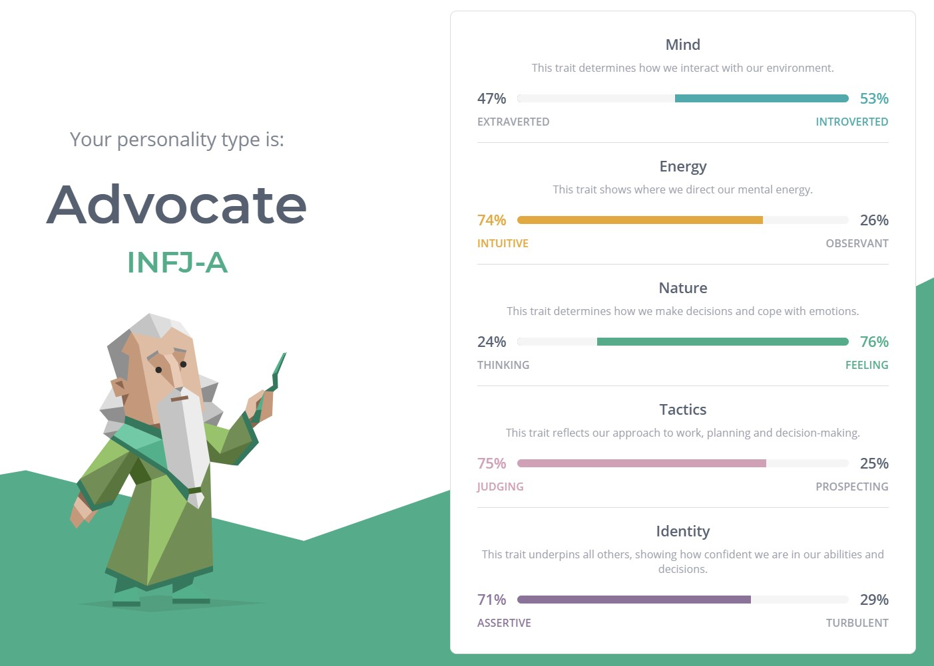

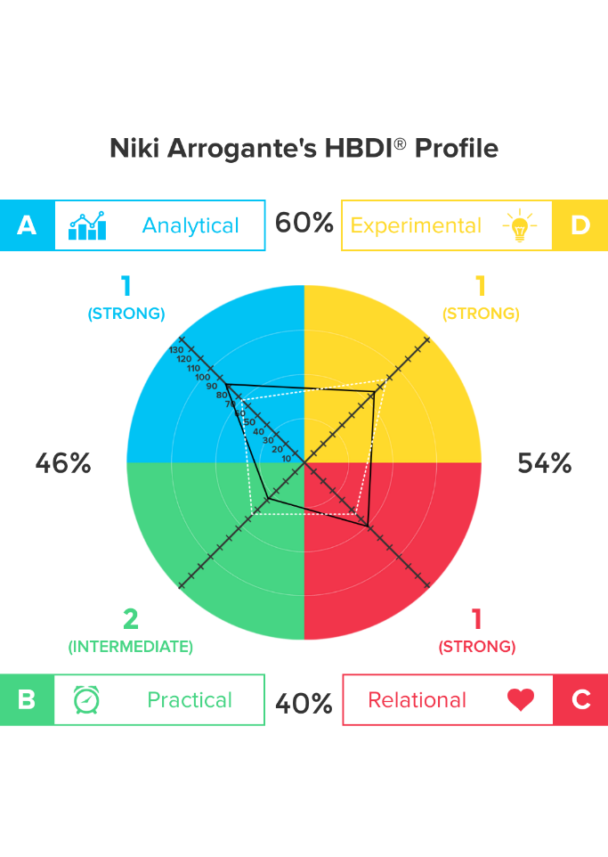

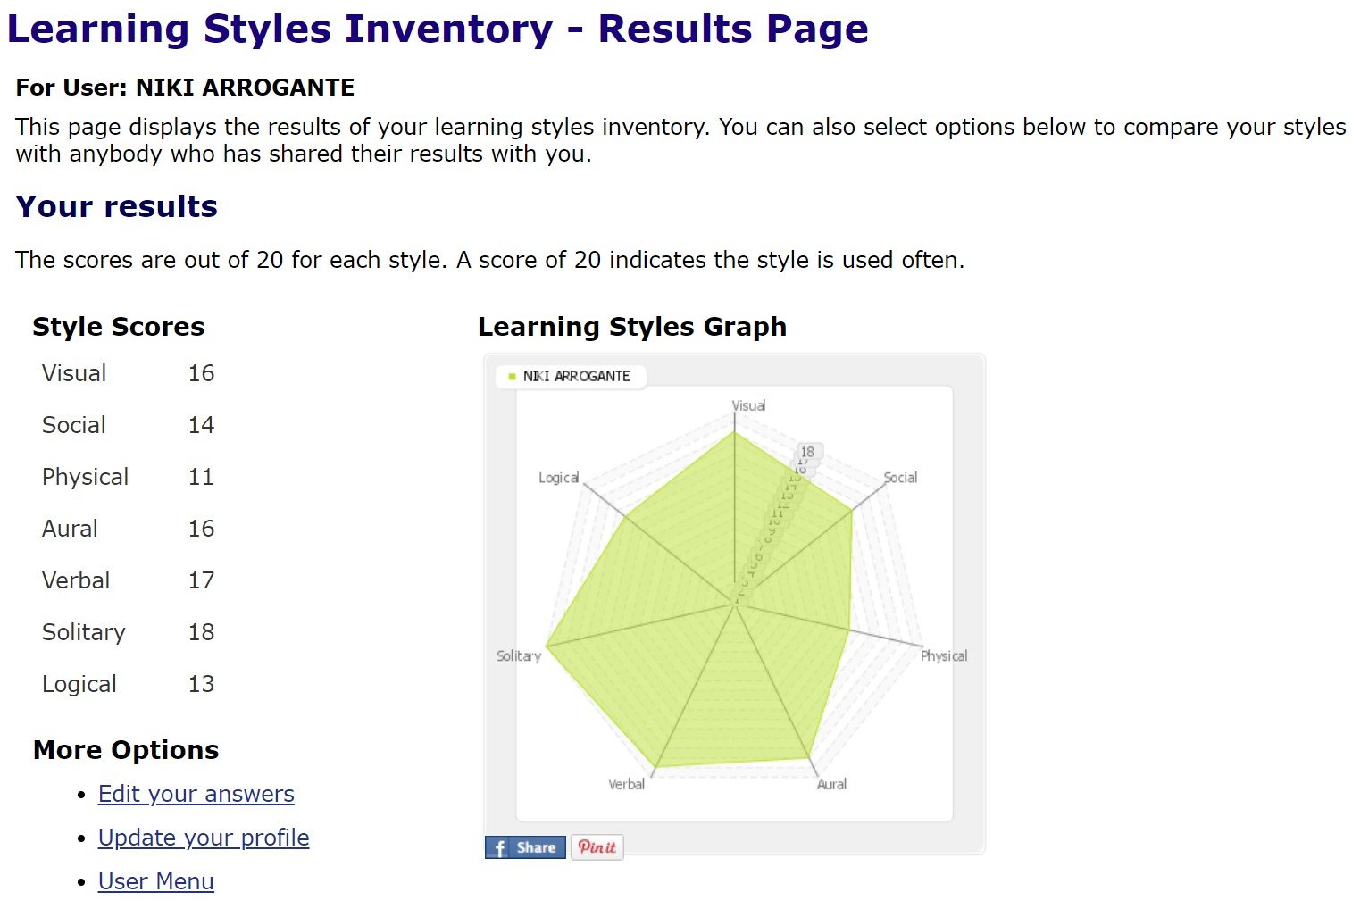

### Tamara Brice

Tamara has been working in the field of Telecommunications for twelve years. Throughout her role, she has worked almost exclusively with enterprise and government contracts specializing in Cisco-managed networks and Wi-Fi. Outside of work she spends a lot of time working on Rally Cars and volunteering with the Australian Communications Radio Monitors (ACRM), The Adelaide Brown Coats and Shine SA, where they run events to raise money for charities. Tamara first became interested in IT during high school, when she started building her own gaming machines. She became heavily invested in gaming, 3D modelling, and making modifications for games.

While she hasn’t had a great opportunity to further her PC programming skills since school, focusing entirely on networking equipment, Tamara misses making small apps and programs, and is excited to find new opportunities.

[Tamara’s Website](https://xerxasjade.github.io/)

Ideal Job: Infrastructure Automation Consultant – Defence

Mara
           16 Personality Test

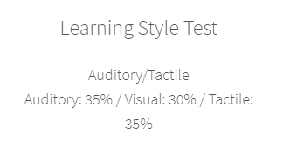

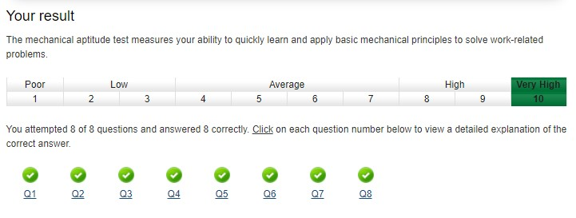

### Debborah Bryce

Mum of four kids, two cats, and two dogs, Debborah was born and raised in Australia with English Scottish heritage. Debborah plays netball on the weekends and currently works in IGA. She is fascinated with modern technology and enjoy learning new skills, languages and reading.

[Debborah’s Website](https://xerxasjade.github.io/Team25/Clone-of-Debs/)

Ideal Job: Data Analyst

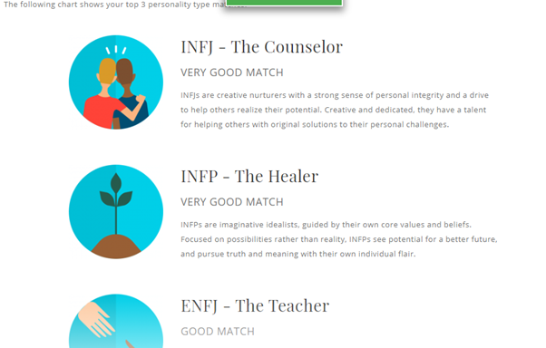

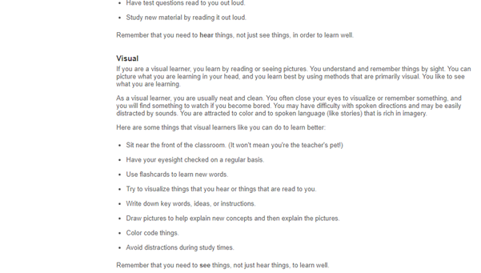

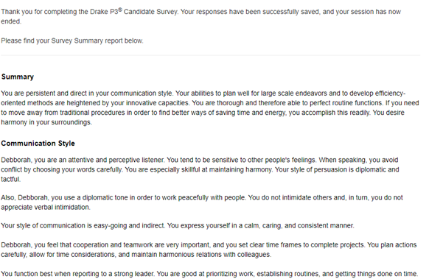

### Samuel Claydon

Sam is a proudly born and raised Tasmanian, living in a rural town named Kempton, which has a population of roughly four hundred. At the age of twenty-three, he is currently undertaking two online courses, our current “Introduction to IT” course, as well as an “Academic and Professional Communications” course. Sam’s passion for video games was discovered thanks to an old computer given to him by a family friend, and he has loved them ever since. After spending a lot of time with a professional computer repairer, he was inspired to pursue a career in the IT industry. <https://cadenmaxwell.github.io/Caden-Profile/>When he isn’t exploring the ins and outs of computers, Sam likes to spend quiet moments with a good book.

[Samuel’s Website](https://samclaydon96.github.io/My-Profile/)

Ideal Job: Computer Repair Technician.

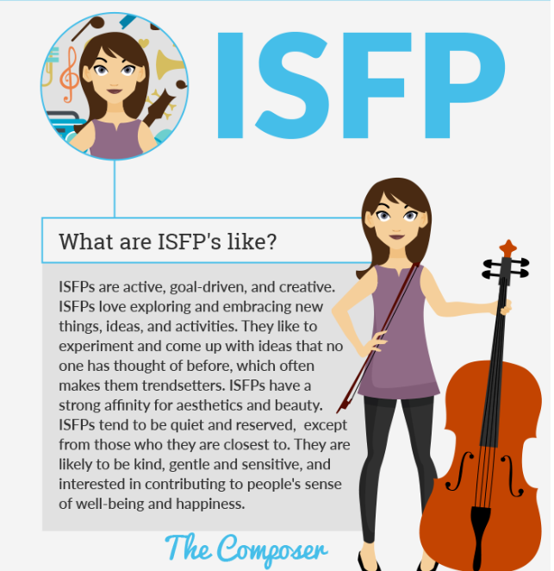

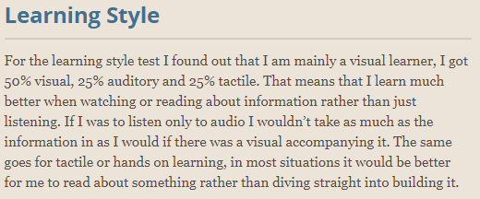

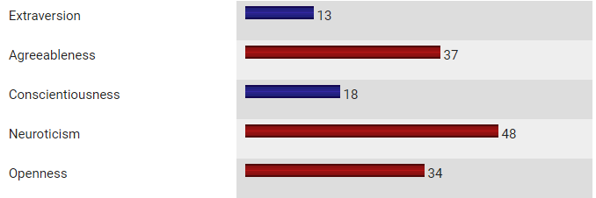

### Caden Maxwell

Caden hails from Wagga Wagga in New South Wales and is of Australian-New Zealand descent. He recently completed his high school and HSC, during which he studied many IT-focused subjects including “Information and Digital Technology”, “Software Design and Development”, and “Information Processes and Technology. Caden is now working his way towards a Certificate III for IT.

Caden was the newest member to the team, but quickly assimilated and contributed greatly to our report.

[Caden's Website](https://cadenmaxwell.github.io/Caden-Profile/)

Ideal Job: Software Developer (Gaming/General Application)

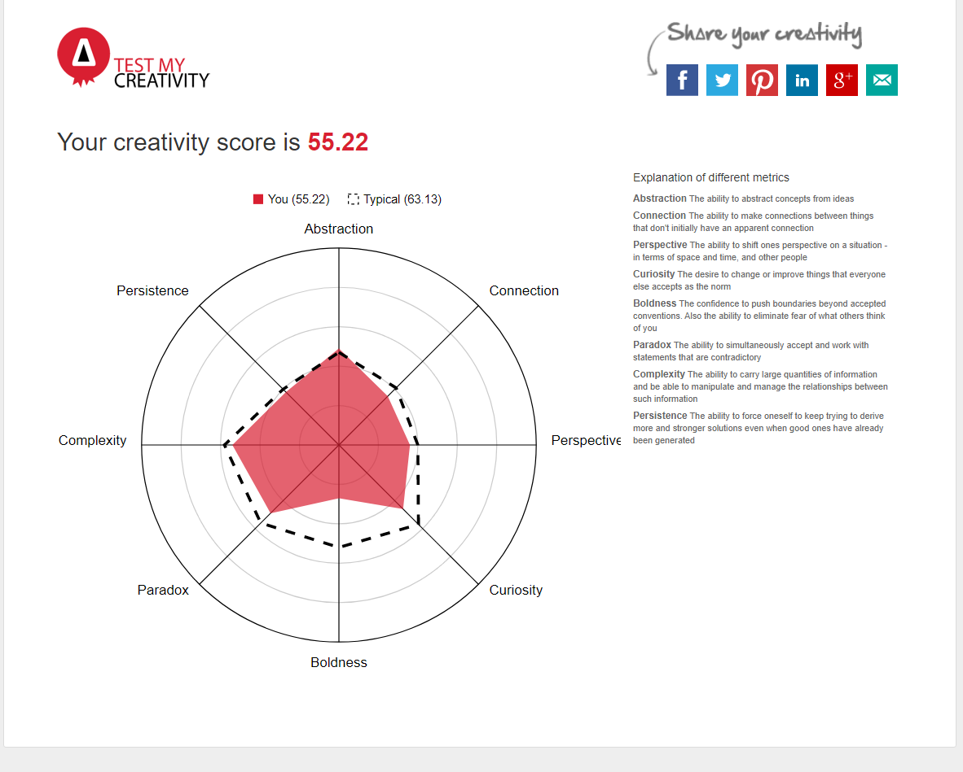

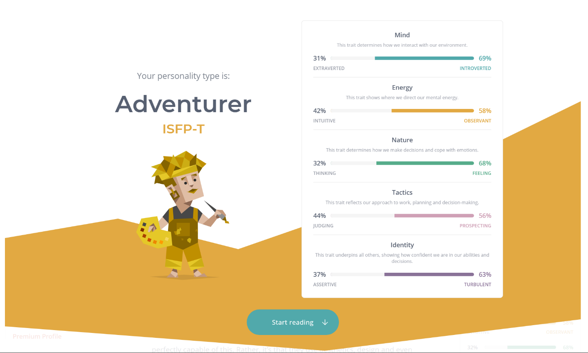

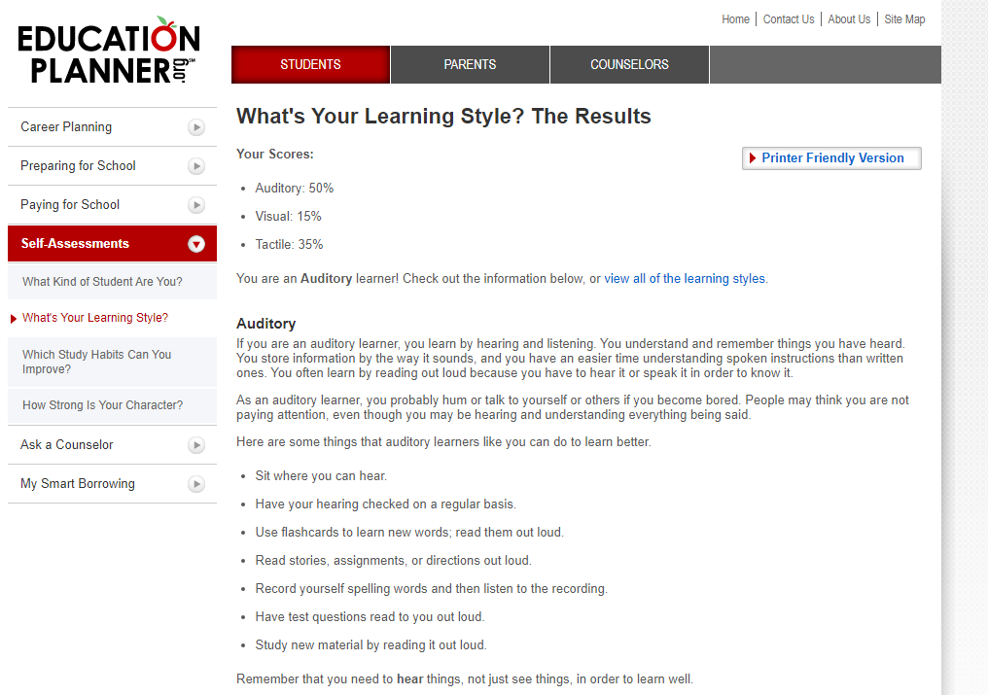

### Jake Waterson

With a background in defence, Jake’s interest in IT steadily built throughout his career. He has worked as a Communications and Information Systems sailor in the Navy, a Desktop Support Technician contractor with the Defence sector, and currently a Systems/Mobility Engineer with exposure to Robotic Press Automation. Jake aspires to learn more about programming and has a keen interest in Cyber Security.

[Jake’s Website](https://darklol93.github.io/Assessment-1/)

Ideal Job: Software Engineer

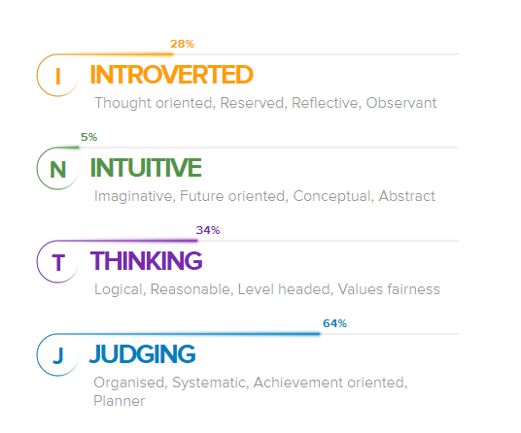

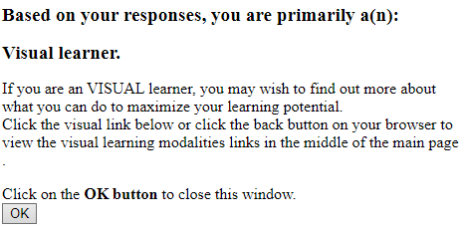

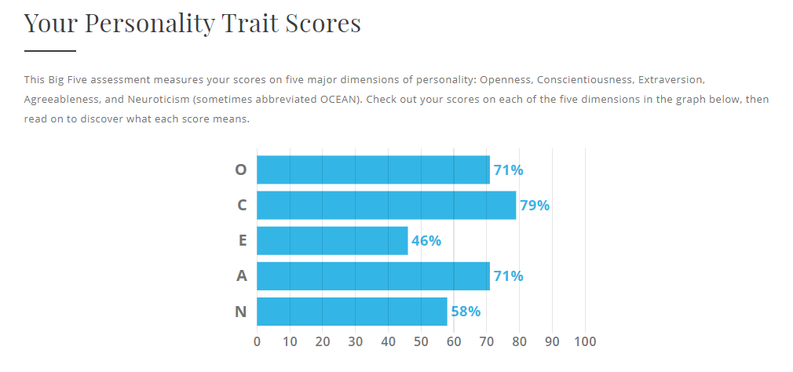

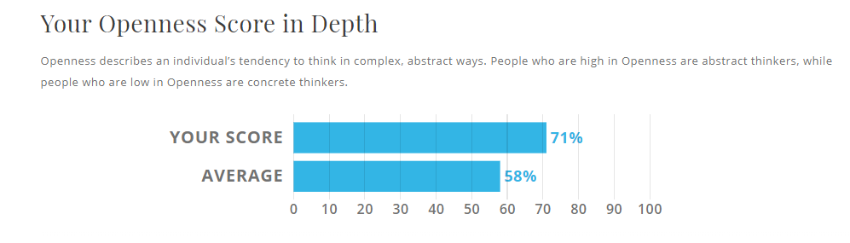

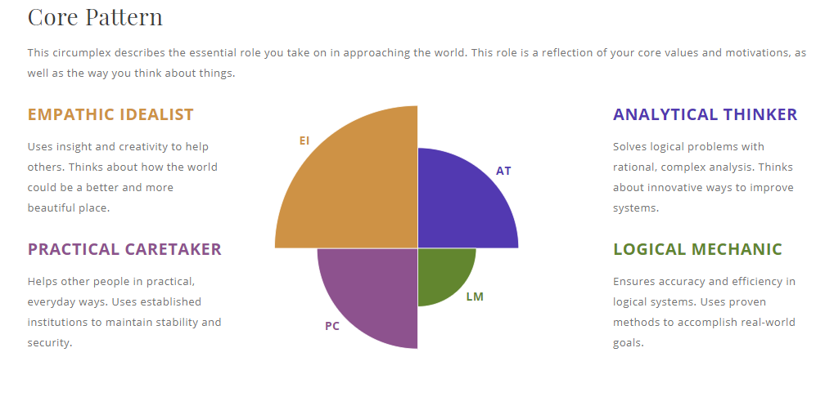

## Comparing Test Results

Our team’s results share common trends in introversion but is otherwise varied in both tests of choice and outcomes. There are strong suggestions that our team could be divided halfway regarding their choices of action when it comes to working as team (when comparing Myers Briggs results), but with an agreement on disciplined organisation and forthright communication, we have not found ourselves challenged by different personalities coming together.

Regardless of seeing our different traits, the team has learned to come together in a short timeframe in order to accomplish our goals.

## Comparing Ideal Jobs

Like our personality tests, our ideal jobs showed variety in the directions we were hoping to take within the industry.

Notably, Samuel’s career choice had the most physicality in the group as a technician, as opposed to the rest of the team directed more towards handling digital information. Jake and Tamara showed interest in working with larger organisations (Google and Defence respectively), while Caden, Niki, and Samuel targeted smaller firms or recruiting agencies and Debborah chose a recruiting agency. We felt that while Niki, Jake, and Caden all were interested in software, the directions they wanted to take their skills were different from each other.

Our conclusion was that we were still early into deciding our careers and found each other’s choices intriguing. In the end, we decided we were still open minded to what the future may bring.

# Tools

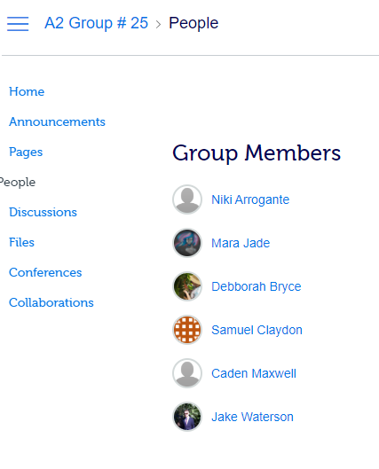

We first assigned ourselves in **Canvas** to [A2 Group # 25](https://rmit.instructure.com/groups/192078). Discussions were minimal as we were preparing for our first assignments, but after our first meeting we decided that our tools would include **Microsoft Teams**, **GitHub**, and **Trello**.

Our [Team Website](http://team25.xerxas.com) was also hosted on our [GitHub repository](https://github.com/XerxasJade/Team25).

## Microsoft Teams

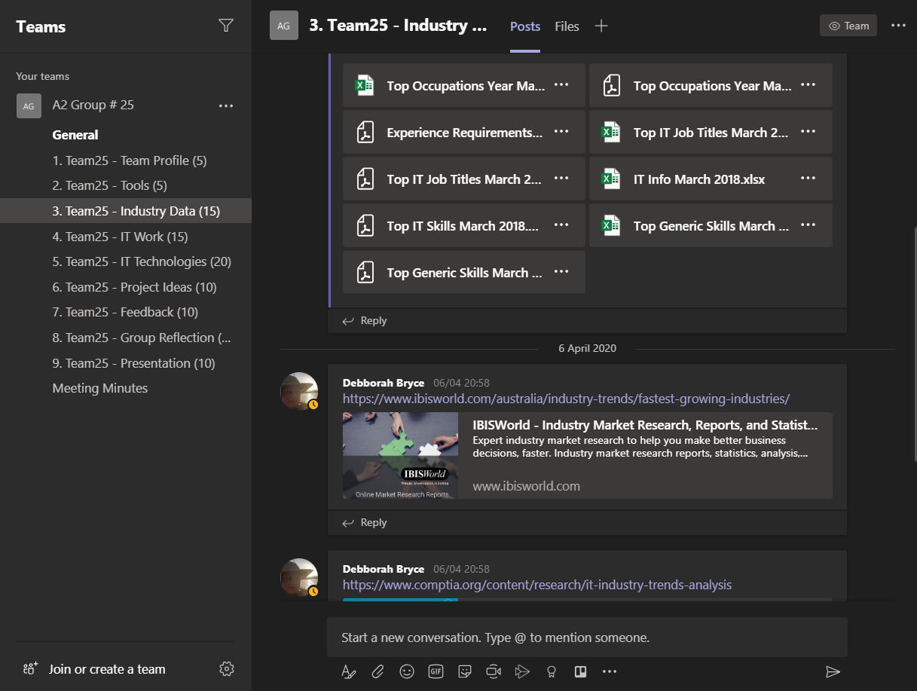

Within [Microsoft Teams](https://teams.microsoft.com/l/team/19%3adae7093f81814e8382f89f14f1afb602%40thread.tacv2/conversations?groupId=df9a1261-3af1-45a1-8b78-c360f7343451&tenantId=d1323671-cdbe-4417-b4d4-bdb24b51316b), we organised separated channels to log our work in different divisions of the assessment as we would be splitting our resources among the sections of the report. Microsoft Teams became the centre of our direct communications, including text and voice meetings and file sharing. Meeting minutes were logged after each meeting for posterity and absent members to make sure we were always up to date with our work and expectations.

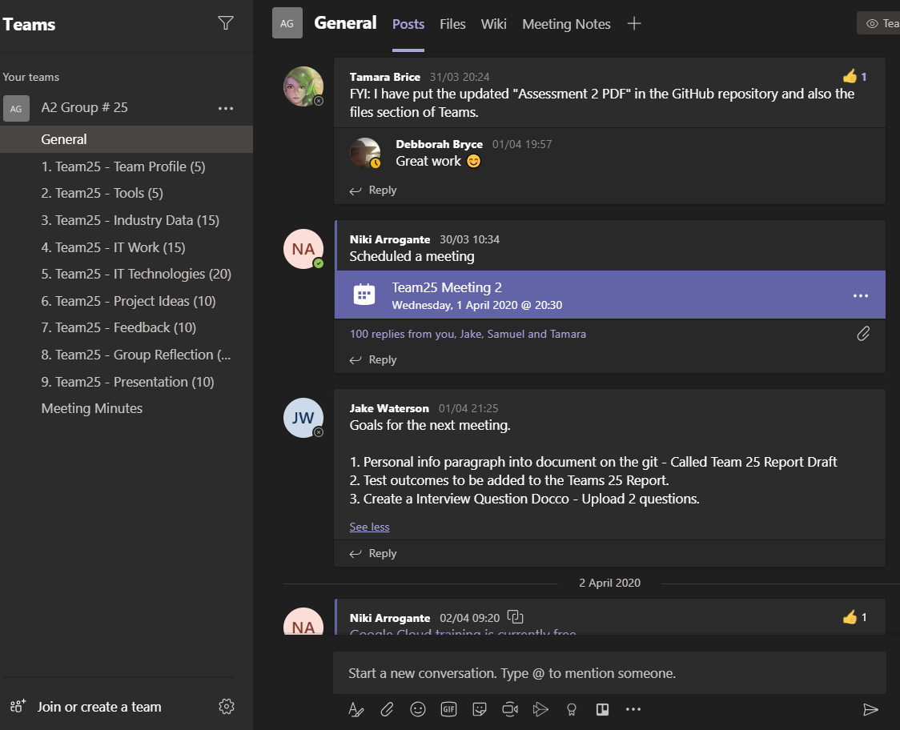

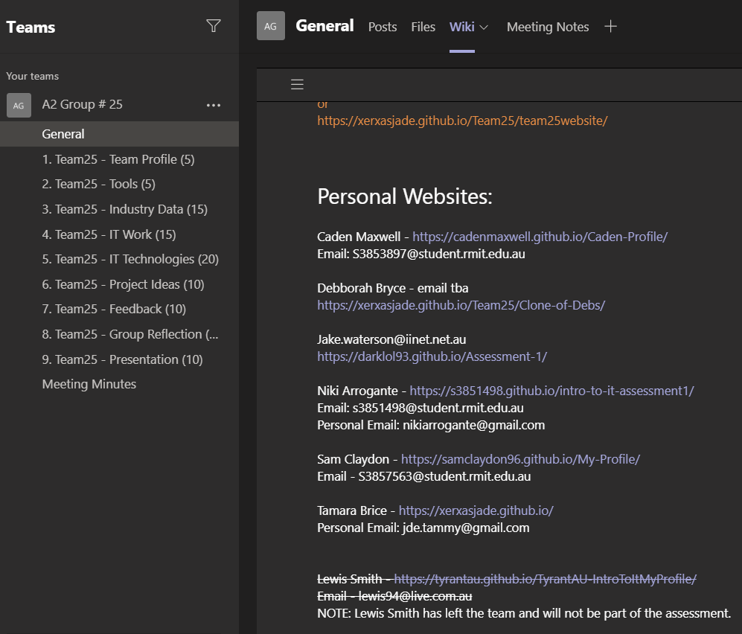

Microsoft Teams proved helpful for keeping our communications steady while we managed our individual availabilities and has been integral to our current success. Through the course of our collaboration this semester, we see ourselves continuing to use Microsoft Teams

## GitHub

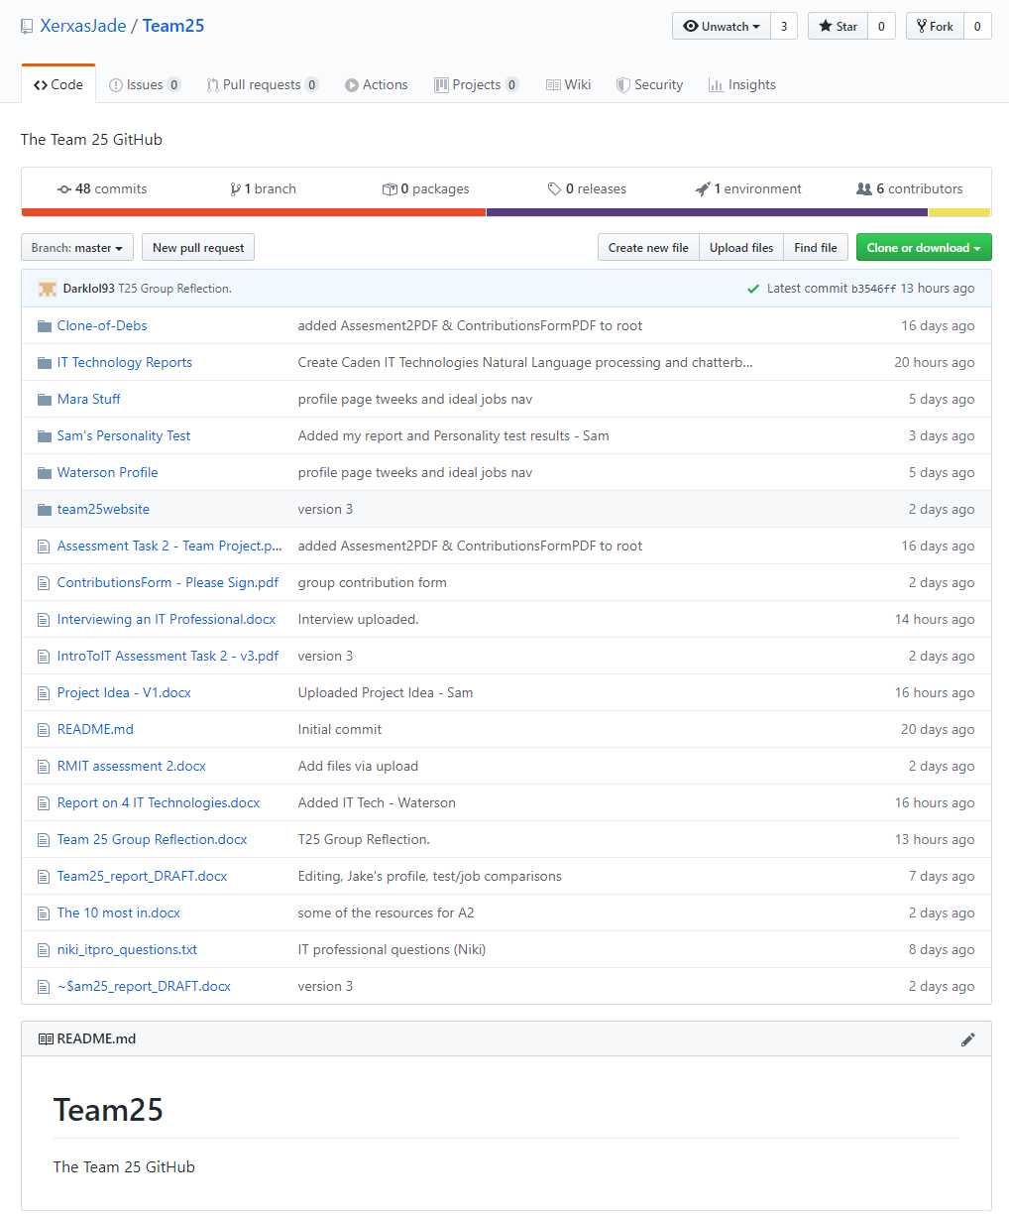

A [GitHub](https://github.com/XerxasJade/Team25) repository was set up to facilitate the team website and act as the repository for our work. Tamara initiated the repository on our behalf, and for the weeks of our assignment it has been seeing regular updates as we made progress. We have found it suitable for tracking our continuing progress, although we were still generally new to the concepts of GitHub.

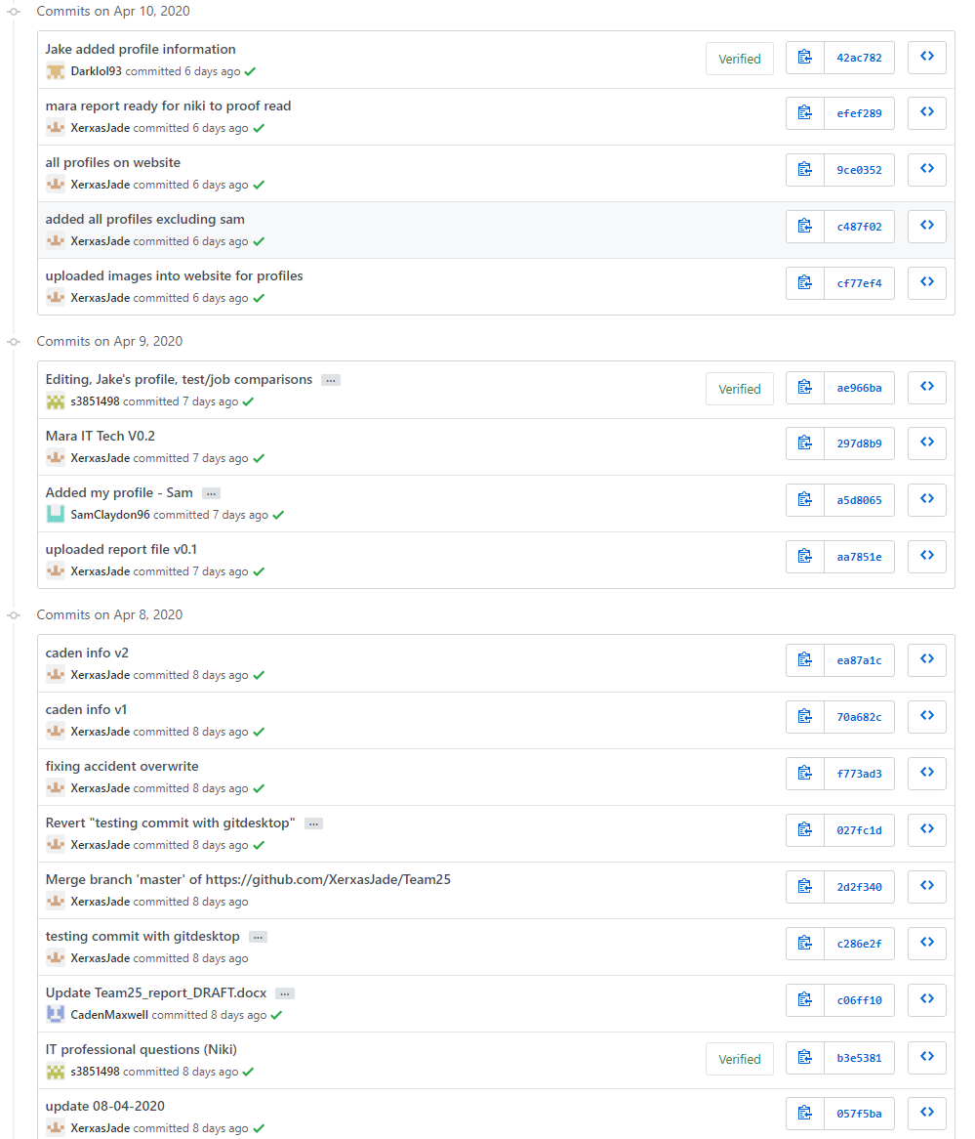

The history of commits was useful motivationally, as it could demonstrate visibly the progress we were making. It was also appreciably helping us all become more acclimated to the GitHub environment, considering many of our ideal jobs would be utilising it in the future.

While we do not believe any of us are able to use GitHub to its full potential, we did agree that it will be very helpful knowledge to us in the long run.

## Trello

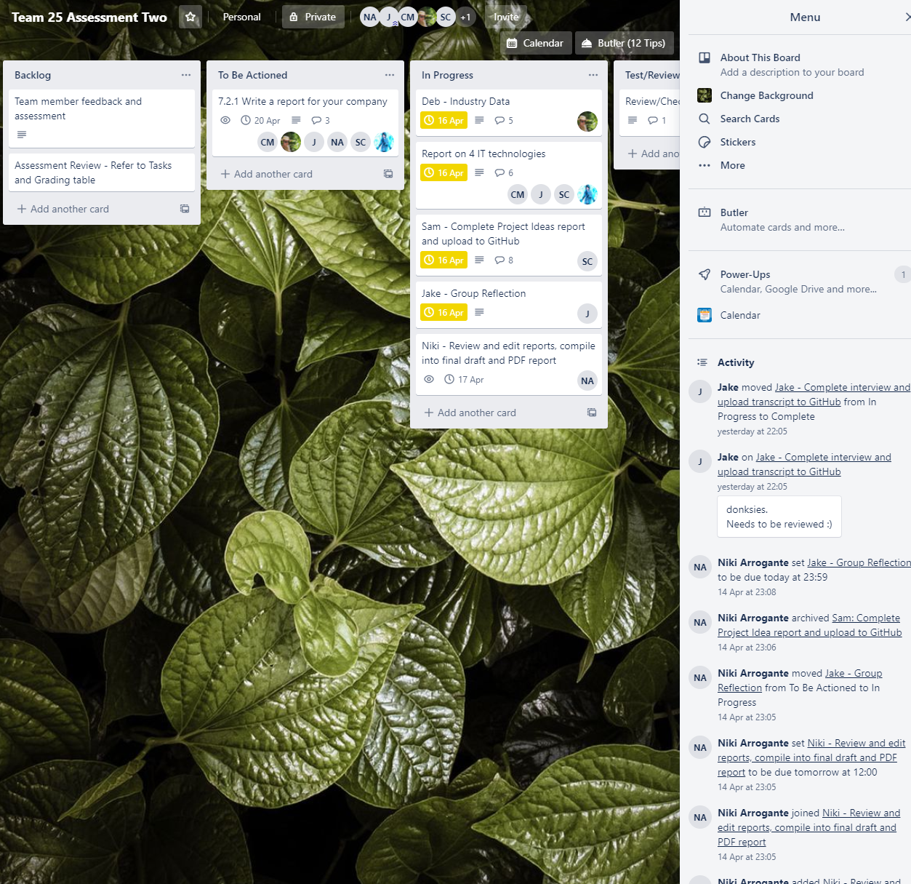

As we were not yet completely versed in GitHub, we opted for an additional method of organising our team to help ensure we were covering all topics. Jake introduced the team to [Trello](https://trello.com/), a “Kanban board”, which is a tool for agile project management. Trello was used to divide our tasks according to preferences, strengths, and fairness.

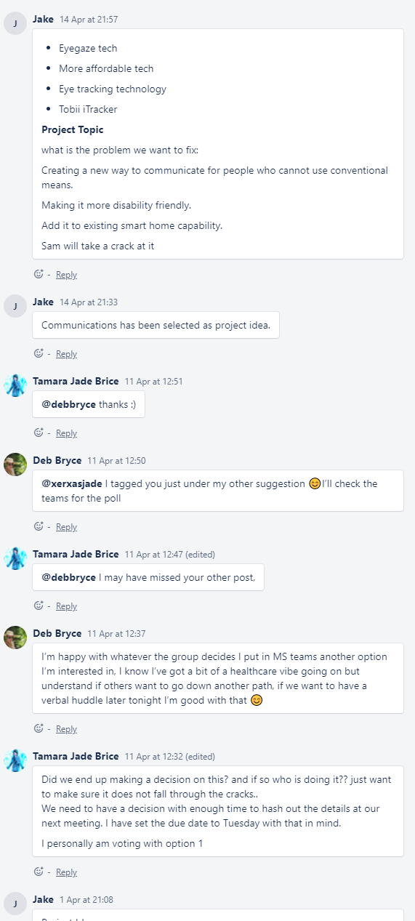

Trello has proven itself to be very user-friendly and straightforward to use, while giving a useful at-a-glance dashboard for our work. The built-in commenting sections were used when having conversations focused on certain topics.

Microsoft Teams also had integration features with Trello and ended up working better in conjunction than expected.

# Industry Data – Research by Debborah Bryce

The Burning Glass data and additional sources were reviewed and analysed by Debborah, detailed as follows:

## Ideal Job Titles and their Demand Rankings

Caden & Niki: Software developer

Jake: Software engineer

Sam: Computer repair

Mara: Infrastructure Automation Consultant

Debborah: Data analyst/scientist

Caden and Niki’s choice, along with Jake, ranked number 1 on Burning Glass top occupation list, 11 in Burning glass top IT job titles, and 15 in top IT skills.

Sam’s choice of computer repair or Computer hardware technician ranks 10 out of 20 in most sort after jobs, according to [Career Karma](https://careerkarma.com/blog/best-tech-jobs/).

Mara’s IT career choice occupation, (the closest I could find) Developmental operations is highly ranked, also according to Career Karma.

Debborah’s occupation choice ranks in the top ten for skills and sought-after jobs according to Burning glass. SQL is the highest ranked skill. Career Karma.com ranked Data Analyst as sixth on their list.

## Skillsets – IT-Specific Rankings

### Software Development (Caden & Niki)

Oral and written communication skills, team collaboration skills, time management, creativity, attention to detail, multi-tasking. Computer coding language such as JavaScript, html, C++, python etc.

Burning Glass ranks communication skills as the highest ranked skill followed by writing, team collaboration and multitasking.

### Computer Repair / Hardware Technician (Sam)

Great working knowledge of available hardware, problem solving skills, circuit board repair and maintenance.

Burning Glass ranks problem solving as the second highest ranked skill.

### Developmental operations, Infrastructure Automation Consultant (Mara)

A good knowledge set including Infrastructure Automation (like Puppet, Chef, Ansible), Project management skills, communication skills and IT security software.

Burning Glass ranks communication and problem-solving skills as their highest ranked skills.

### Data Analyst/Scientist (Debborah)

Time management, Problem solving skills, Communication skills, Writing skills, Knowledge of statistics and data analysis.

IT specific: Programming languages, such as SQL, Oracle and Python data visualisation, dashboard and report creation.

Communication is Burning Glass’s top ranked skill.

### Software Engineer (Jake)

Problem solving skills, communication skills, product knowledge, practical experience in software creation/development, excellent knowledge in applications, programming skills and customer service.

## Skillsets - General Rankings

The general or soft skills listed in the team’s skillsets are all highly ranked, particularly Communication skills and problem-solving skills. These skills are not just important to the IT industry, but to any career choice.

## Highest Ranked IT Skills Not Required in Our Skillsets

Business management.

Building relationships.

Business analysis.

(Burning Glass Data)

## Highest Ranked General Skills Not Required in Our Skillsets

Planning.

Creativity.

Leadership

(Burning Glass data)

## Has Our Opinion of Ideal Job Changed?

As this was my share of the assignment the team agreed to let me answer this on behalf of them.

After all the sourced data was reviewed the team are still very eager to pursue their chosen job titles, each team individual has been in interested in their respective job choices long before this assignment and now if anything have a better understanding, based on the data used, of what is required both in general and specific skills sets

## References

Learn to Code With Me. 2020. *17 Best Technologies To Learn In 2020 (And Where To Learn These Skills)*. [online] Available at: <<https://learntocodewith.me/posts/tech-skills-in-demand/>> [Accessed 14 April 2020].

Crabtree, C., 2020. *Best Tech Jobs: The 20 Best Jobs In Tech For 2020 And The Future*. [online] Career Karma. Available at: <<https://careerkarma.com/blog/best-tech-jobs/>> [Accessed 14 April 2020].Burning glass data extracted from RMIT Canvas Assignment 2 specs.

# IT Work - Interview

Jake interviewed a colleague on our behalf in order to provide some insight on someone working in the industry. Joel McInnes, a Wintel Team Lead from ASG Group, was asked a series of questions we put together for some practical information.

The following transcript details the responses we received to our questions:

1. **What kind of work do you do?**

I’m a Midrange Server Team Lead for a department of the Federal Government. My daily duties involve coordinating a team, liaising with clients, standard incidents and changes, and work on infrastructure projects.

1. **What kinds of people do you interact with? Other IT professionals? Clients? Investors? The general public?**

Working client-side, I interact with individuals inside and outside of my department. Other than my team members in Midrange, Desktop, and Service Desk teams, I also regularly communicate with service delivery managers and external service providers (including Microsoft, Mobile Iron, and Content Keeper.

When preparing for legal proceedings I’ll be in touch with lawyers too. And typically, I always have clients that I’ll touch base with regularly, anywhere from CIOs to the general public.

1. **Where does the IT professional spend most of their time?**

I spend most of my time onsite with my clients, however with the current crisis I complete my work at home for the time being. I’ve now had a thrilling increase in teleconference and video conference meetings!

1. **What aspect of their position is most challenging?**

Managing multiple projects in a very agile environment, while ensuring service continuity. Changes can create their own form of chaos, so you must be able to adapt quickly to new situations in these roles.

1. **How is your work life balance affected when working in the IT industry? Are there any noticeable benefits or disadvantages working in your field?**

This depends entirely on the role you are in.

I’ve been employed in several roles as a Midrange Engineer where, for a two-year period, due to the nature of the engagement, I was on-call 365 days a year. It was difficult to get days off-duty until I was able to justify (by taking on additional work & contracts) a second staff member.

Bearing in mind, this was on a Defence contract where the support base is huge. It paints a picture clearly that no matter how large the client, you can in some instances be on your own or in a very small regional team.

In my current role, I have an excellent work-life balance.

While I do often work 10 hour days as a Midrange Team Lead, this is entirely by choice and I am able to utilize those additional hours worked to claim TOIL later, in effect giving myself the opportunity to work hard in the short term and be rewarded with additional time off in the future.

What you get out of these roles, is often as much as you put in.

1. **What kind of environment are you surrounded in, in your profession? How do the people in this environment positively or negatively affect you?**

As a Midrange Team Lead supporting a Federal client, I am surrounded by both staff and our contracted client.

In this position, I can be positively affected by the efforts of my own staff in their self-development activities and in many cases, this positive effect is passed on to our client in our ability to service them – this gains us a positive working relationship with our client and is a fundamental part of ensuring that a contract renewal can also occur.

Positive outcomes from proactive staff are only one of many ways in which this can take place. Positive engagements with our client are something I continue to strive for – not only is it our role to support the client to our contract SLA’s, but it is the wider userbase who see the benefits of this effort.

Negative engagements can and do occur. If an issue arises with a supported technology or an ongoing project, the impact can be felt across the entire support base. These can have seriously adverse effects on the team as well, and when these do happen the workload for the team is increased dramatically.

Some of the metrics that will see serious downturn are: client happiness, staff happiness (due to additional workload, especially in instances out of hours work), staff fatigue (burnout is real and more common than you think), things of that nature.

These events carry the potential to impact any future opportunities such as additional project engagements.

1. **What is the most challenging part of your job and how do you overcome these challenges?**

No day is ever the same.

While this is incidentally the most rewarding part of the job, it also means that you will continually face a new challenge.

To overcome these challenges, I often find myself reading vendor articles on common faults, known issues, or even an emerging technology. As we attempt to provide a solution to a question that has only just been raised, the world shifts to another method of working.

The current crisis is a prime example – answering the question of how to get 1500 users from desktop’s, our to access remotely, either from a device with a VPN tunnel back in to the domain, or Citrix – which as you consider your own phases of planning to respond to a request from a client, will have a flow on impact on your support footprint.

1. **What advice can you give to people interested in entering the IT industry?**

Don’t shy away from self-improvement outside of business hours.

The degree you are doing now, the study you might do outside of this, such as a VMware VCP, a Microsoft MCP, a Cisco CCNA, or any other certification will do you wonders as you progress your career.

Not only do you gain a practical understanding of the items you may support, but you show to a potential employer you are willing to learn.

Granted, a lot can be learnt on the job too, so don’t shy away from ‘shadowing’ a more senior member of staff – asking ‘stupid’ questions is the best way to learn.

That said, some things I learned the hard way were:

* If you don’t know, read the knowledge base.
* If you don’t have a knowledge base, Google the vendor knowledge base
* Google a reddit post on the product and look up experiences from other technicians
* NOW you refer to your senior tech in the team
* Escalate to an appropriate technical internal resource (or Team Lead)
* Engage the vendor through a support agreement if you have one
* Document the fix in the team’s knowledge base – if they don’t have one, start one.

Don’t go asking for help the first sign you don’t know the answer, the best way to self-improve, is to start searching for the answers yourself.

The best lessons you will learn are the ones you find the answers for yourself.

# IT Technologies

## Cybersecurity – Research by Tamara Brice

### What does it do?

Cybersecurity is designed to prevent unauthorized malicious access to IT technology such as networks, programs, devices and systems. Cybersecurity is a multifaceted field of study which requires all the different types of security to work together and function a whole to be affective. Some of the more common parts of cybersecurity include physical security of key systems, network security, remote logging and monitoring, redundant systems and end user education.

One of the key elements of maintaining cybersecurity is education, because without education of the end user a sophisticated security system can be easily bypassed. If the end user opens an infected email or falls victim to a phishing attack, a hacker will have instant access to their device. Phishing and ransomware are the two largest leading forms of cyberattack and is costing the global economy in excess of $600 Billion a year. These two forms of attack are based on human error, and the only way to strengthen the defence against this is education of the end user. This is a growing field that companies are starting to take a lot more seriously, and it is an area where a lot more development is still needed. In conjunction with training, limiting user privileges to restrict the installation of unauthorized software can further minimize the risk associated with falling for one of these attacks. It is also important that strong rotating password requirements are implemented across a company to try and prevent the success of brute force password attacks.

From a network perspective, implementing access control lists, VLANs, and subnetting can all be used to segregate a network and in doing so, reduce the risk. By dividing the network up, should a breach occur, the hackers do not have unlimited access to the whole network. Additionally, implementing a VPN and network encryption can increase security by making it improbable that a hacker could reverse engineer the data contained within the packets without knowing the encryption keys.

An often-overlooked part of cybersecurity is physical security. There is an old saying along the lines of, “if they’ve already plugged into the network, you’ve lost the battle”, which is a great summary of why physical security is so important. You could have the best firewalls and encryption available but if a hacker can physically plug into one of your network switches or access an authorised computer already on the network, they will able to bypass all the security measures. This is particularly important in remote branches and data centres where there is a greater chance of unauthorised access. Remote branches tend not to be as secure, as often the onsite staff are not familiar with the necessary security measures and contractors may be accidentally granted access to the IT equipment. Data centres have shared space with many different companies, and any company can grant access to a contractor, meaning no one person knows who should have access to the building. This makes potential intruders difficult to detect as you can’t be sure who has been given access to the equipment rooms, or their intentions. Ensuring that unused ports are shut down and cabinets are locked is a good way to combat this problem and should be standard practice (but sadly in my experience, it is not).

Cloud based monitoring and reporting are another important part of cybersecurity, with the aim of early detection of possible threats. If a threat is detected early enough, cybersecurity staff can implement changes to reduce the likelihood of a breach or stop a breach in progress. Through the correct implementation of alerts on network hardware and server software, cybersecurity staff can receive automatic notifications when security risks occur, such as: unauthorised rogue connections (both wired and wireless), eavesdropping/spoofing, and denial of service (DDOS) attacks, to name a few.

Redundancy is good IT practice whether for security or general operations. Specifically, from a security standpoint, redundancy allows you to recover from attack more quickly using a backup to recover any lost data. Backup storage can also be used to identify what has been stolen if hackers erase or damage primary storage.

### What is the likely impact?

Nearly two thirds of people who use the internet regularly have had their data stolen or compromised at some point. In 2019, it was estimated that 1.5 trillion dollars was lost from the global economy to cybercrime. This has a huge impact on the bottom line of governments and large corporations, as the cost to maintain security and recover losses is passed on to the general population through increased prices, fees and taxes. At a more individual level, identity theft can cause significant disruption to people’s lives. When it comes to identity theft, the impact isn’t always financial. Depending on the goal, it could be to discredit someone, corporate espionage, domestic violence or stalking. With current security technology becoming so effective when implemented correctly, hackers will continue to use human-centric approaches such as phishing, malware and trojan-horses, to gather credit card details and personal data. This is the most straightforward way for a hacker to achieve their goals, with a lot of resources and how-to’s available on the internet, and minimal coding experience or knowledge is required. With a 20% increase of ecommerce hacks over the last 12 months, fraudulent credit card activities are going to continue to grow. This has a great impact on the retailer and the individual whose details were stolen, causing financial losses and stress. This will also influence banks who need to constantly improve their monitoring of accounts to better detect fraudulent purchases.

As the increase in hacking and fraud continues to grow, more jobs will be created in the cybersecurity industry. Unlike other areas of IT, such as automation, this field is unlikely to make jobs in other areas redundant, as security is not a replacement for an existing product. The cybersecurity industry will continue to grow to meet the increasing demand.

### How will this affect you?

The more I’ve learnt about cybersecurity, the more I think it would be an interesting job prospect. Working towards making better code, better algorithms or even AI that could detect potential vulnerabilities and attacks, prior to the need for human interaction will minimize the risk of human error, which is the most common point of failure in a security system.

This has already affected my day to day life, with companies implementing two-factor authentication to increase the security of my accounts. For example, banking sending my mobile an SMS code before a transfer can be made or having to enter in a security code when signing-in to a new Apple device. Steam requires two-factor authentication just to log in, to prevent an intruder stealing product keys from your games. Google now sends security alert emails to your account when logging in from a new device. All new modems now come with a minimum a basic Wi-Fi password and most now require a login to access the GUI. More companies are accepting PayPal instead of credit card payments because of an increase in demand as more people want secure ways to pay online and minimize their risk.

Phishing emails are getting harder to detect at first glance, and more people are falling for them. This affected me as recently as February this year, when my ISP’s web mail accounts were hacked, and the hackers were able to use this password to access many of my parent’s accounts that shared the same password. It took me several days to reset all the passwords to new unique passwords, and to go back through banking records to verify that there were no fraudulent charges.

I know multiple people who have been hacked, and even after experiencing this, people can still fall for the same techniques and scams. If people continue to fall for these techniques, hackers will continue to use them. This is a huge problem when dealing with sensitive information and we all need to be vigilant.

### References

Cisco. 2020. *What Is Cybersecurity?*. [online] Available at: <<https://www.cisco.com/c/en_au/products/security/what-is-cybersecurity.html>> [Accessed 6 April 2020].

Cyber.gov.au. 2020. *Home Page | Cyber.Gov.Au*. [online] Available at: <<https://www.cyber.gov.au/>> [Accessed 6 April 2020].

GBHackers On Security. 2020. *A Rising Of E-Commerce Cyber Attack & Most Dangerous Threats Of 2019*. [online] Available at: <<https://gbhackers.com/a-rising-of-e-commerce-cyber-attack-most-dangerous-threats-of-2019/>> [Accessed 6 April 2020].

Hashed Out by The SSL Store™. 2020. *The Top Cyber Security Trends In 2019 (And What To Expect In 2020) - Hashed Out By The SSL Store™*. [online] Available at: <<https://www.thesslstore.com/blog/the-top-cyber-security-trends-in-2019-and-what-to-expect-in-2020/>> [Accessed 6 April 2020].

Itgovernance.co.uk. 2020. *Cyber Security*. [online] Available at: <<https://www.itgovernance.co.uk/what-is-cybersecurity>> [Accessed 10 April 2020].

Mcafee.com. 2020. *Economic Impact Of Cybercrime Report | Mcafee*. [online] Available at: <<https://www.mcafee.com/enterprise/en-au/solutions/lp/economics-cybercrime.html>> [Accessed 8 April 2020].

Minute, 2020. *Cybercrime Costs Global Economy $2.9M Per Minute*. [online] Infosecurity Magazine. Available at: <<https://www.infosecurity-magazine.com/news/cybercrime-costs-global-economy/>> [Accessed 9 April 2020].

PhoenixNAP Global IT Services. 2020. *17 Types Of Cyber Attacks To Protect Against In 2020*. [online] Available at: <<https://phoenixnap.com/blog/cyber-security-attack-types>> [Accessed 8 April 2020].

Rand.org. 2020. *Examining The State-Of-The-Art In Cybersecurity*. [online] Available at: <<https://www.rand.org/randeurope/research/projects/cybersecurity-state-of-the-art.html>> [Accessed 9 April 2020].

Technology.org. 2017. *Biggest Cyber Attacks And Their Cost For The Global Economy*. [online] Available at: <<https://www.technology.org/2019/07/17/biggest-cyber-attacks-and-their-cost-for-the-global-economy/>> [Accessed 9 April 2020].

Us.norton.com. 2020. *Do You Worry About Cyber Safety? Learn Some Smart Defenses.*. [online] Available at: <<https://us.norton.com/internetsecurity-malware-what-is-cybersecurity-what-you-need-to-know.html>> [Accessed 9 April 2020].

## Clouds, Services, and Servers – Research by Samuel Claydon

### What does it do?

Cloud services and servers are examples of cloud computing, which is used to host various types of services and applications online. Cloud computing comes in three different forms: Infrastructure as a Service (IaaS), Platform as a Service (PaaS), and Software as a Service (Saas). These services are provided by companies with the hardware to support said service, which is then made available to rent for people or organisations who require it. Cloud services and servers have become a necessity in today’s world, as just about every business needs to have some sort of network set up to manage their organisation in the digital age.

“Infrastructure as a Service” refers to online resources like storage or servers are rented out for the buyer to use for their products. This is what a new company or one moving to the cloud would buy to get started. Renting cloud servers is a very affordable alternative to setting up servers and paying for maintenance on them, while easily being able to scale the number of servers that are being rented. Users of IaaS have reported that it has cut down time to deploy new applications and largely reduces maintenance costs. However, some users believe that the security when using IaaS is lacking for the safe storage of important information (Steve Ranger 2018).

“Platform as a Service” refers to online platforms that are rented out and used by buyers to develop and host their applications. PaaS is used to provide developers a platform which they can use to create and test applications. This service comes with the software and tools needed to develop applications and lets multiple developers work on the project remotely. Like IaaS, this service allows companies to create applications without needing to set up the infrastructure to do so which saves money and time.

“Software as a Service” provides users access to software that is hosted online, so there is no need to download it. SaaS is the most common type of cloud computing because it’s easy to implement and understand, and it can be used in a variety of applications. Hosting the software online has the benefit of being instantly accessible anywhere with an internet connection, and ultimately available on a multitude of devices. Users don’t have to install and manage the product, and any issues that occur can be fixed without the need for the user to update.

The current leading companies in the cloud computing industry are Amazon, Google, and Microsoft. These companies are currently offering their own version of a hybrid service, combining IaaS and PaaS into one platform. People using these platforms can develop applications using all the tools a PaaS will provide, while having access to servers and storage an IaaS gives without the need to buy two separate services. These companies are providing the latest technology with their services, including strong security systems that relieve some of the worries users were having about cloud storage not being secure.

The future of cloud services is serverless computing, which despite its name is not actually serverless, but refers to a type of cloud service where the user never has to log on to or access the server themselves. Using serverless computing the buyer wouldn’t have to manage their own cloud servers as it would be done automatically, the service would automatically scale based on usage and bill based on that. There are some examples of serverless computing already, such as AWS Lambda which lets the user put in a small piece of code which will only run when called, and they will be charged based on how many times the code is run. There are many reasons why serverless computing platforms aren’t widespread yet, the main one being that they just don’t have the capabilities of a normal cloud service yet. Serverless clouds rely on event-driven architecture and API calls and design to function, and as these technologies are further developed serverless clouds will become more widespread.

### What is the likely impact?

Cloud services and servers are versatile in what they can do, and what they’re used for can vary greatly between users. Common uses include private and public cloud storage, data backup, creating and using apps online, and social media. Cloud technology has provided an easy way for new businesses to start an online database without the large upfront cost of buying and maintaining servers.

It also makes it easier for workers to communicate with each other on projects remotely, meaning not everyone needs to be in the same place to work together. Just about everyone will use cloud services at some point in their lives, with a lot of people using them multiple times a day. It’s provided new opportunities for many people to learn or work with and has provided people with more ways to communicate with family and friends or even meet new people online. With COVID-19 going around, many schools and workplaces have unfortunately had to shut down. But thanks to a variety of different cloud services, several of these places have been able to continue what they were doing via the internet. Thanks to online education apps such as Blackboard or Canvas most schools have been able to continue teaching their students online, and some businesses have been able to continue working thanks to apps like Microsoft Teams.

With more and more businesses moving their databases to the cloud, it will inevitably affect the people who work these companies. They’ll need to learn how to work with the new system, and some may face role redundancy due to the company no longer needing onsite server management. However, more businesses moving to the cloud means that there will be a bigger market for cloud server providers, and more jobs will open in the field, hopefully creating new opportunities for these people.

### How will this affect you?

Cloud services becoming more common has already affected me quite a bit in a good way. Online education is becoming more common which means it’s easier to find a course I want with a good school, not only that but it makes it easier when doing schoolwork in a group. Until recently, I never realised how good applications like Microsoft Teams and GitHub are for working with a group, it’s easy to stay connected and keep up with the work they’re doing. I recently started online schooling with two different schools and in those courses, I’ve had to use two different online education tools, Canvas and Blackboard. Both are easy to use and it’s easy to find what needs to be done online and get feedback from teachers.

It’s hard to say how it will affect people who don’t use technology a lot, like my family. Most people use cloud services like Netflix or Facebook on a day to day basis, and I’m sure with the virus keeping people at home more services like Netflix will be more popular than ever. Like a lot of people my friend in America recently had to start taking classes online, and if that wasn’t an option, she would have had to miss out on a lot of school like a lot of others would have. In the future there will probably be many more jobs that are based online and will be able to be done from home, which will mean that it will be easier to get a job in a rural area like where I live. On the contrary with more businesses moving to the cloud it might be hard to get a job in certain fields. I think it would be interesting to learn more about cloud services and how to run them in case I want to go into a career in this field in the future.

### References:

Amazon Web Services 2020, *What is AWS,* Amazon Web Services, viewed 12 April 2020,  
<<https://aws.amazon.com/what-is-aws/>>

Bernazzani. S, *IaaS vs. PaaS vs. SaaS: Here’s What You Need to Know About Each,* blog post, 12 September, viewed 11April 2020,  
<<https://blog.hubspot.com/service/iaas-paas-saas>>

Castro, P, Ishakian, V, Muthusamy, V, Slominski, A 2019, ‘The rise of serverless computing’, *Communications of the ACM,* vol. 62, pp. 44-54,  
<<https://dl.acm.org/doi/pdf/10.1145/3368454>>

Dave Anderson 2020, *Serverless computing: An ‘exciting space for engineers to play in’*, Silicone Republic, viewed 12 April 2020,  
<<https://www.siliconrepublic.com/people/serverless-liberty-it-dave-anderson>>

Fastmetrics n.d, *What Is Cloud Computing & How Does ‘The Cloud’ Work?*, Fastmetrics, viewed 11April 2020,   
<<https://www.fastmetrics.com/blog/tech/what-is-cloud-computing/>>

Google Cloud n.d, *Cloud Computing Services | Google Cloud,* Google Cloud, viewed 12 April 2020, <<https://cloud.google.com/>>

IBM n.d, *IaaS PaaS SaaS Cloud Service Models*, IBM, viewed 11 April2020, <<https://www.ibm.com/cloud/learn/iaas-paas-saas>>

IBM Cloud Education 2019, *What is a Cloud Server?,* IBM Cloud Education , viewed 11 April 2020, <<https://www.ibm.com/cloud/learn/cloud-server>>

Microsoft 2020, *Cloud Computing Services | Microsoft Azure,* Microsoft, viewed 12 April 2020 <<https://azure.microsoft.com/en-au/>>

Steve Ranger 2018, *What is Cloud Computing? Everything you need to know about the cloud explained,* ZDNet, viewed 11 April 2020,   
<<https://www.zdnet.com/article/what-is-cloud-computing-everything-you-need-to-know-from-public-and-private-cloud-to-software-as-a/>>

Techquickie 2014, *What is “The Cloud” as Fast as Possible,* Youtube, 26 Febuary, Techquickie, viewed 12 April 2020  
<<https://www.youtube.com/watch?v=dsKIpLKo8AE>>

## Natural Language Processing and Chatterbots – Research by Caden Maxwell

### What does it do?

Chatbots date back to 1966 with the first chatbot “ELIZA”, however you may know chatbots as the latest “Alexa”, “Google Assistant” or “Cortana”. Chatbots used to be text-based, where you would type out a sentence and they would reply to it. They wouldn’t be able to have a conversation with you like today’s chatbots. They were mainly used for therapy sessions, but these ‘sessions’ weren’t beneficial, and the bot usually just replied with “How does that make you feel?” and other similarly simple questions. But as time went on, chatbots evolved. Now we have chatbots like “Evie” and “Cleverbot”.

Evie used the API of Cleverbot, so they were similar. However, Evie had one distinct difference. Evie had a face and a voice, she was able to communicate through sound, and facial expressions and the most exciting part about Evie was that she collected the conversations from everyone using the chatbot, and would adopt her lexicon to be able to converse with a broader range of communications. She was able to keep up with the popular slang of the time and became very popular among internet users and started to spark the interest of chatbots.

Natural Language Processing (NLP) works in conjunction with chatbots to allow the chatbot to collect user inputs and construct an intervention based off its own AI. Without NLP, chatbots would suffer significantly and lead to either bad conversation or incorrect responses.

Today we are used to the likes of “Alexa”, “Siri” or “Google Assistant” which not only perform what previous chatbots could but also allows us to control devices in our homes or get news from local sources using our voices from across the room. Current chatbots are compatible with many different devices that have changed the way we automate our lives, and we can use them to switch lights on and off, play movies on our tv, lock and unlock doors, and more.

The possibilities of chatbots today seem infinite. Over the next few years, we could see some brilliant things happening with our home automation and even something outside of our house. Cars are becoming more advanced especially with the rise of Tesla and the fantastic technology that they come equipped with, Tesla has already started with their own chatbot, however now it is constrained and only works on Facebook Messenger, but give it three years and you might be able to tell your car to park out the back using an Alexa device from your room or ask it to unlock before you even leave your house.

The evolution of chatbots are a considerable focus in technology, Home automation systems have gotten prevalent, and now they are being pushed to be better and better. Typical chatbots would generally reply purely based off user input and a lot of the time the chatbot would not have an answer. But with the growing increase of Artificial Intelligence (AI) chatbots will become more advanced and personal, they will be able to learn things about the user making the experience much more efficient. Instead of the user asking for something, the chatbot might be able to ask the user if they should perform an action according to previous knowledge.

### What is the likely impact?

With chatbots ever growing and becoming more advanced the way we go about our day to day lives will drastically change, a lot of the things we would do manually will be done using our voices, taking away the need to get up and turn the tv off, or switching on a light or turning on the oven or microwave, there is an abundance of things that could change. We would no longer need to go grocery shopping. Our houses would be automated so that everywhere in the home you could tell it to do something and it would be able to act on the request.

A substantial demographic that would be affected by this would be elderly and the disabled. For a lot of people in impaired circumstances it is difficult to do things manually and require assistance. However, with the use of chatbots, they would be able to perform more activities without having to put themselves in danger.

The advancement of chatbots can significantly improve the quality of life for users. However, there is always the concern of privacy, and in today’s day and age, privacy is a big worry, and we don’t know who is listening to us and when.

Chatbots aren’t suited for the work environment, as they are more used to convey information. An excellent example of how these could be used in the workforce, however, is when someone needs to type out long transcripts of conversations like in courts, the transcriber could ask their chatbot assistant to listen and type out the conversation. Then the transcript can be later checked over to make sure it’s feasible for the job. Chatbots are not used to replace jobs, but to enhance the ability to do a job.

### How will this affect you?

I use chatbots every day already, I mainly use it to control my lights, music and I ask about the weather, I also use it to help me get around on my food delivery trips. I am ready to accept future chatbots into my life to help improve the quality of life of my home or work experience and am excited to see where the future of chatbots can take us.

In my household, we have a total of 3 Alexa units, one in my room, my sisters’ room and in the kitchen, and we each use them differently every day. My sister uses hers to help with her studies in high school and the kitchen Alexa is used for recipes, timers and to add some comfortability to the home and play some music where we can gather and hang out. Alexa has increased our togetherness of our family and has made doing simple jobs like cooking and cleaning much more enjoyable and comfortable.

### References

Philips, C., 2020. *Natural Language Processing (NLP) & Why Chatbots Need It*. [online] Medium. Available at: <https://chatbotsmagazine.com/natural-language-processing-nlp-why-chatbots-need-it-a9d98f30ab13> [Accessed 13 April 2020].

Carpenter, R., 2007. *Eviebot At Www.Eviebot.Com*. [online] Eviebot. Available at: <https://www.eviebot.com/en/> Accessed 14 April 2020].

Carpenter, R., 2006. *Cleverbot*. [online] Cleverbot. Available at: <https://www.cleverbot.com/> [Accessed 14 April 2020].<https://passage.ai/introducing-teslabot-v-2-0-a-passage-ai-chatbot-powered-by-smartcars-api/>

Suthar, S., 2018. *11 Chatbot Trends To Watch For In 2020 - Acquire*. [online] Acquire. Available at: <https://acquire.io/blog/chatbots-trends/> Accessed 14 April 2020].

## Robotic Process Automation – Research by Jake Waterson

### What does it do?

Robotic Process Automation (RPA) is a developing technology and is a part of the Artificial Intelligence community. It is governed by business logic and structured inputs, which is aimed at automating business processes*.* Using RPA applications, an engineer can configure a robot to record and interpret many applications. These applications can include (but are not limited to) processing transactions, manipulating data, initiating responses and communicating with other technology systems.

RPA lets someone engineer a ‘robot’ to emulate the task or tasks of humans or computer processes. The only difference being is, that a robot never has to sleep and if configured correctly does not make any mistakes. As stated previously, robots can emulate humans so they are capable of whatever a human can do on a computer. For example, a robot can log into applications, copy and paste information, move files and folders and many other tasks.

There are 3 trends that appear to be shaping the future of RPA:

* Developing RPA solutions for easy deployments. Leading Providers are currently working on developing their applications in containers, which will simplify deployment as well as making it easier to migrate to different cloud services.
* As RPA evolves around repetitive business tasks, developers investigating ways to further integrate RPA with other technologies.
* As products become similar, we can expect to see some open source varieties

Whilst implementing RPA, it is highly suggested to develop a “Centre of Excellence” (CoE). A CoE is a governing body of the RPA team that looks at which processes might take priority, or what will make the most significant business impact. Whilst doing these processes, it gives the business the opportunity to review processes in general. Although they might not get to be incorporated into an automated task, it allows the CoE to improve the current process if necessary.

One of the best advantages that RPA can provide is better value for time and efficiency. Below, you will read about an example of a company utilising the technology to mitigate staffing and timing issues to undertake a contract that the business has been awarding.

### What is the likely impact?

There are many theories about how robotic automation has and will impact people. Firstly, we can discuss the positive outcomes. RPA can drastically reduce the time that a human conduct repetitive or time-consuming tasks. One of the best examples I can give is from a webinar I heard recently: a company had obtained a contract to value approximately sixteen thousand properties. After being told that they won the contract, they had two weeks to start valuing the properties. Now the issue that the company was faced with was that it would take approximately sixty days to hire new resources and onboard them.

This is where RPA came in. A technology company introduced RPA into the business and within ten days they had all the necessary infrastructure installed, and a robot had been constructed to help undertake the valuing task. The robot was able to gather the necessary information from the desired web resources within eight days of coming online. That’s eight days of continuous work.

There are two ways at looking at the above scenario, there is both positive and negatives. The positive is that RPA was a time affective solution, mitigating the 60-day timeline to hire and onboard new staff. This allowed the business to achieve its outcome for their client. However, if you look at it from another point of view, that one robot replaced human jobs. This can be an ethical and moral question: what if people needed those jobs? It brings with it concerns that businesses might use robotics to slowly start replacing humans in order to lower expenses.

As seen, there are both potentially positive and negative effects of Robotic Process Automation technology. The purpose of RPA is not to replace its human counterparts in the workforce. It has been designed to help increase the performance of the existing workforce. The idea of automation has been around since the creation of the first computer systems and programs. It can be assumed that RPA will eventually be replaced by a capable artificial intelligence.

### How will this affect you?

RPA currently affects me in my day to day life as I work with an automation team in my role. Working with the team, vendors, and clients, it is very eye opening how this technology can have a positive impact on the IT Sector. I am slowly planning how to use this technology to in my daily tasks. How can I set it up to make these reports for me? How can I implement RPA with our security monitoring tools? When these tasks are set up, it will increase proficiency in both the reports and start investigating security activities instantaneously.

RPA has the potential to impact my family in a beneficial way. Especially my Dad and his colleague, who operate the South Australian Division of their business. If they were able to get their monthly reporting and quoting automated, they would be able to focus a lot more on the field operation side of the business.

### References

AiMultiple, POSTED ONMARCH 22, 2020. *Future of RPA: In-depth Guide to RPA Innovation in 2020.* [Online]   
Available at: <https://blog.aimultiple.com/future-of-rpa/>  
[Accessed 11 April 2020].

Boulton, C., 4 SEPTEMBER 2018. *What is RPA? A revolution in business process automation.* [Online]   
Available at: <https://www.cio.com/article/3236451/what-is-rpa-robotic-process-automation-explained.html>  
[Accessed 11 April 2020].

Kelemen, Z., Jun 2, 2018. *Impact: How RPA and AI Technologies Will Affect the Job Market.* [Online]   
Available at: <https://medium.com/slalom-technology/impact-how-rpa-and-ai-technologies-will-affect-the-job-market-b54045a5e598>  
[Accessed 11 April 2020].

Taulli, T., 25 Jan 2020. *RPA Center Of Excellence (CoE): What You Need To Know For Success.* [Online]   
Available at: [https://www.forbes.com/sites/tomtaulli/2020/01/25/rpa-center-of-excellence-coe-what-you-need-to-know-for-success/#20f4b5f2287a](https://www.forbes.com/sites/tomtaulli/2020/01/25/rpa-center-of-excellence-coe-what-you-need-to-know-for-success/%2320f4b5f2287a)  
[Accessed 11 April 2020].

Truniger, J., June 26, 2018. *Robotic Process Automation: Why It Can't Replace Humans.* [Online]   
Available at: <https://www.appway.com/screen/blog-press/id/Robotic-Process-Automation-Why-It-Can-t-Replace-Humans-1519763602473>  
[Accessed 11 April 2020].

UiPath, UNK. *AUTOMATION IS THE FUTURE OF WORK.* [Online]   
Available at: <https://www.uipath.com/rpa/automation-first>  
[Accessed 11 April 2020].

UiPath, UNK. *Robotic Process Automation.* [Online]   
Available at: <https://www.uipath.com/rpa/robotic-process-automation>  
[Accessed 11 April 2020].

# Project Idea

Team25’s project idea is designing and building high-tech glasses with eye-tracking capabilities, with the focus of providing a way to communicate for people with impairments limiting their ability to communicate with traditional methods (such as speech or body language). There are currently devices that can do this, but they are currently expensive, require additional equipment to work, or otherwise impractical to be commonplace. Our design proposition will combine augmented reality technologies with smart automation to allow its user to communicate through their environment and attempt to lessen the entry costs by having our technology adapt to existing ones (namely, home automation). We hope developing this technology will allow the less able to communicate more effectively with their family, friends, and caretakers.

The glasses would have inbuilt eye tracking that would allow the user to navigate through an augmented reality interface that would encompass their everyday needs in communication. Smart home automation would be connectable with the glasses, and using a virtual keyboard directed by eye movement, messages could be sent through networked systems both aural and written. We envision the device to be capable of allowing users to operate household devices with as minimal outside support as possible, including activities such as: operating a television, using a computer, or making a phone call.

A large part of our idea was directed towards use in the health industry as a tool for caretakers that need more viable communication pathways with their patients. Care facilities could create automated environments to suit their patient’s conditions, and open new communication channels to help the carer and caretaker relationship standards improve. Users would be given higher agency in their environment by being able to watch television of their own accord or adjust their room’s temperature. We believe this concept of agency could provide benefits to the recovery and/or therapy of the individual.

An emergency system is proposed for the device as the targeted userbase are made up of individuals who are more at risk and can find themselves in dangerous situations when unmonitored and disconnected from others. The plan would require that the eye-tracking software is taught typical warning signs made by the eyes, or a “panic manoeuvre” to be made by the user to contact the relevant help services.

The technology required to build our glasses already exist in forms such as Google Glasses. Our challenges would involve the costs to manufacture, creating a design that is safe for use by users susceptible to seizures or panic attacks, and engineering software that can provide these services at a level that is fit to purpose.

With these glasses people who previously had no way to communicate with others would be able to talk to people again, and much more on top of that. The ability to ask for help or tell others what they’re going through will benefit a lot of people and give caretakers all over the world a way to better assist their patients. It will also give disabled people a new way to interact with their environment, even if it is limited.

# Group Reflection

## Niki

Working with everyone in Team25 has been a refreshing experience, as I reluctantly gave up a more studious life to take a more responsible role in my family. Even with one of our members changing out halfway through, the relationship I’ve had with the group has been amicable, responsive, and very respectful to one another.

I think our communication with one another went impeccably. Using MS Teams meant we could just catch up with each other on our own time, much like a group chat. Everyone pulled their weight and supported each other, and I thought that was great.

Frankly I don’t believe any major improvements were needed. Workflow was strong, everyone was open to each other’s feedback, and everyone did their best. I have no complaints. I’m also not really the type to be surprised by anything, I’ve worked in a multitude of environments and adapt quickly. I suppose if anything, I’m surprised how well this assessment went given we all met each other just a few weeks ago and come from different walks of life.

One thing I’ve learned about groups is that there’s always a way to make it work. Just need to find yourself in good company. The time I’ve spent working with Mara, Jake, Deb, Sam, and Caden has been smooth sailing, and I believe we have a great mix of characters and walks of life.

Our GitHub log isn’t a perfect representation of our work in my opinion. We used Trello and MS Teams at the same time, so our timeline of work is scattered amongst them, and we were always in touch so keeping work on personal drives was easier while researching. In hindsight, I think we should have decided more strongly on one primary method for keeping our work, but in the conditions of our assessment we did the best we could with what he had and what we knew.

## Tamara

Overall, I think our team worked really well together. We laid out detailed plans at the beginning of the assignment using Trello and were able to quickly to divide up the work amongst the team with minimal hassle. By using Trello and Microsoft Teams for most of our communication we were able to make sure that everyone knew what they should be doing and when it needed to be completed by.

I feel that one of our strengths was that if anyone needed help there was always someone who could assist, and the team worked well together with no major conflicts.

Credit must go to Niki for his organizational skills, Niki was great at making sure that nothing got missed and that the team was on track and focusing on the correct goals. I feel like the GitHub log by itself does not reflect our team’s effort, because I have significantly more commits than anyone else. This was partly due to my involvement on the website and pushing things up to test them on the live environment. Whereas other team members did their work offline and only pushed finished products. I feel like the group divided the work very evenly and this is much better reflected on Trello and MS Teams than the GitHub log.

I think communication in our team has been very strong and we've worked together in a way that made use of each other's strengths and weaknesses. we have a lot of complementary skill sets and I look forward to working with the with Tim 25 for future projects.

## Debborah

This has been an interesting project; I’m still getting used to University level learning and producing projects. The current situation of COVID19 interfering with our ‘normal’ lives and routines has defiantly made this task more stressful than need be. Being and essential worker, single parent to 3 children at home and helping them with their home schooling has probably resulted in me not producing quality work but being a part of Team25 has defiantly lifted my spirits.

Mara was a great help in helping me fix my failed GitHub hub attempt from assessment 1, Niki has been very good at leading the group and keeping everyone on track, he obviously has natural born management skills. Sam and Caden where late entries into our team but have caught up and been available. Jake has also been very good at facilitating the Team online discussions.

I’m looking forward to completing more projects with Team25 and hopefully, moving forward my time management and organisation skills will improve.

## Samuel

Overall, the group was amazing, everyone did their part and we got all the work done in time. If anyone asked for help, there was always someone there to help them. I could say that we could have managed our time better, but due to COVID-19 that’s not fair because everyone is going through a lot right now, besides we still got everything done with time to spare.

One thing that surprised me is how many great apps there are for group work. It’s been a while since I’ve done any group work and things like Teams and GitHub make everything a whole lot easier.

I think that my GitHub log reflects my activity but I’m not sure about the others, I know Niki and Jake both did work that might not be in the GitHub logs. Something I’ve learned is that as long as you communicate with your group everything will work out fine. I’m excited to do more work with Team 25 and I hope they feel the same.

## Caden

Team25 worked very well together and were able to work around tricky scheduling. They were very welcoming to me even if I joined three weeks late and were able to catch me up to speed and have me put in my input to the group in no time. Team25 was on top everything, and work structure was organised, so it didn’t seem like a muddled-up mess.

Something that could be improved is our GitHub organisation. There were a lot of files and folders all over the place, making it hard to see what was essential and what was temporary.

Something surprising to me was that even though we all have pretty different lives and are at varying ages and backgrounds, we all clicked and were able to work very well with each other.

That not all groups are a waste of time, a lot of the time I am placed in groups that really could have just worked better if I did the work by myself, however, Team25 was very helpful, and everyone did their bit.

Our GitHub, although messy and a bit unorganised, shows the amount of work we put into this assessment, as of right now there are 63 commits, a lot of work went into this assignment. Our GitHub shows that we tried our best and getting out as much as we can so it can be as clear and concise as possible.

## Jake

I think as a group, we’ve done exceptionally well. It’s brilliant when several individuals come together, then walk away as group with a result. In the early lectures is was mentioned that one of the hardest things doing group assignments was communication. And I believe that is something we really excelled in. Between work lives, personal lives and the current issues that we have been presented with, we were able to organise weekly meetings and have consistent communication utilising teams. We regularly checked in to see what tasks where outstanding and to make sure everyone was doing okay, in case some people were struggling and needed help.

Additionally, I love it how the team came together. Everyone had the strong and weak points and we utilised them to work through this assignment. Early on someone mentioned they weren’t to confident with technology and others said they were confident using the git platform. Personally, I thought people speaking up like this and so soon was great, because usually it takes a while to open up like that.

Finally, I would like mention that it in a lot of my working career and now education. This team is one of the best I have worked with. They way everyone gelled together, took responsibility for their work, asked for help. It all tied in together and we were able to produce a successful outcome.

## Team25

Our collective agreement is that our teamwork was present and working from the beginning. We believe the maturity of the group was key to reaching the end goal. We were open with one another, brought up concerns early, and respected what each of us was able to give to the team. Because we always had a clear picture, we could execute our plans and achieve results.

We have also been sensitive to the current epidemic scenario (COVID-19) and was sure to check on our individual wellness throughout this time. We were more accepting of deadline difficulties and unavailability, and this helped keep the morale high.

For improvements, we feel that we would have performed better had we more experience with our tools. Using three tools at the same time, and not having discussed organisational habits (file naming, comment structures) we used more time than needed ensuring we were opening the correct files or looking at the right resources. We’ll try to correct this as we continue in the course.

A surprising aspect for the team was that towards the end of the assignment we felt we hadn’t achieved adequate work. However, after spending a moment going through the assessment together and checking everything off, our work was more realised than expected. We are quite proud of the result.

What we learned about groups, by being grouped together, was that having a strong selection of strengths amongst the team helps to overcome our individual weaknesses. In the early stages we were objective about our capabilities with techniques and technologies and tried to capitalise on our best traits.

Our team agrees that the only way to have a full understanding of our progress would be from the combined analysis on all our tools combined. The GitHub audit trail alone is only representative of a small portion of work, mostly for the website preparation. The screenshots earlier in the report of Teams and Trello may give an idea of how our work transpired across the three applications. Access to our Teams and Trello tools is available upon request.

# Credits

Niki Arrogante – s3851498 – Report Editor/Designer, Organiser

Debborah Bryce – s3853719 – Industry Data Researcher, Head of Project Concept

Tamara Brice – s3851505 - Cybersecurity Researcher, Website Manager

Samuel Claydon – s3857563 - Cloud Researcher, Project Idea Writer

Caden Maxwell – s3853897 – NLP/Chatterbot Researcher

Jake Waterson – s3857894 - Interviewer, RPA Researcher, Meeting Manager